HUMBLE SIGN
LEAD TO QUOTE
PROCESS FLOW DOCUMENT

Login to Role: Sales Manager
Creating Lead
Leads are companies or individuals who represent potential customers. In NetSuite, leads are the first step in the sales cycle that progresses to prospect and then to customer.
Sales organization evaluate leads through a qualification process that measures their ability and willingness to purchase. When a lead is viable, it is ready for assignment to a sales representative
Navigation: Leads -> Relationships -> Leads -> New
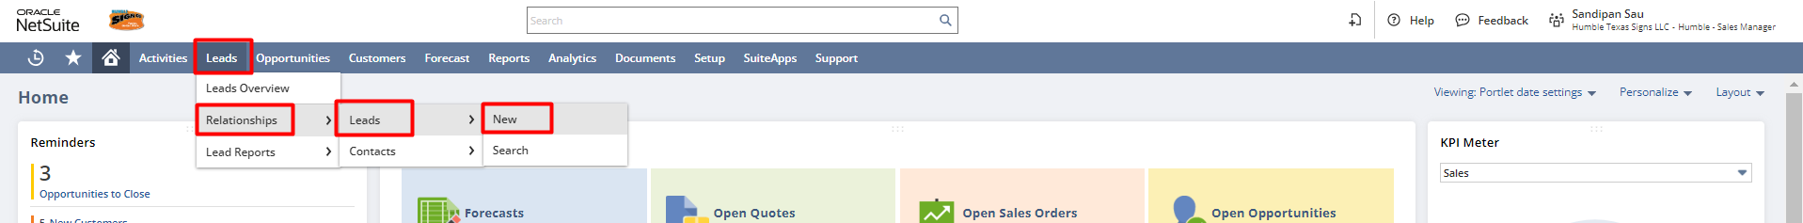

In the Lead form select Type, enter the Company/Individual Name, Primary Subsidiary (If multiple subsidiaries are present), Lead Status, Email, Sales Rep (If a sales rep is associated), and Lead Source
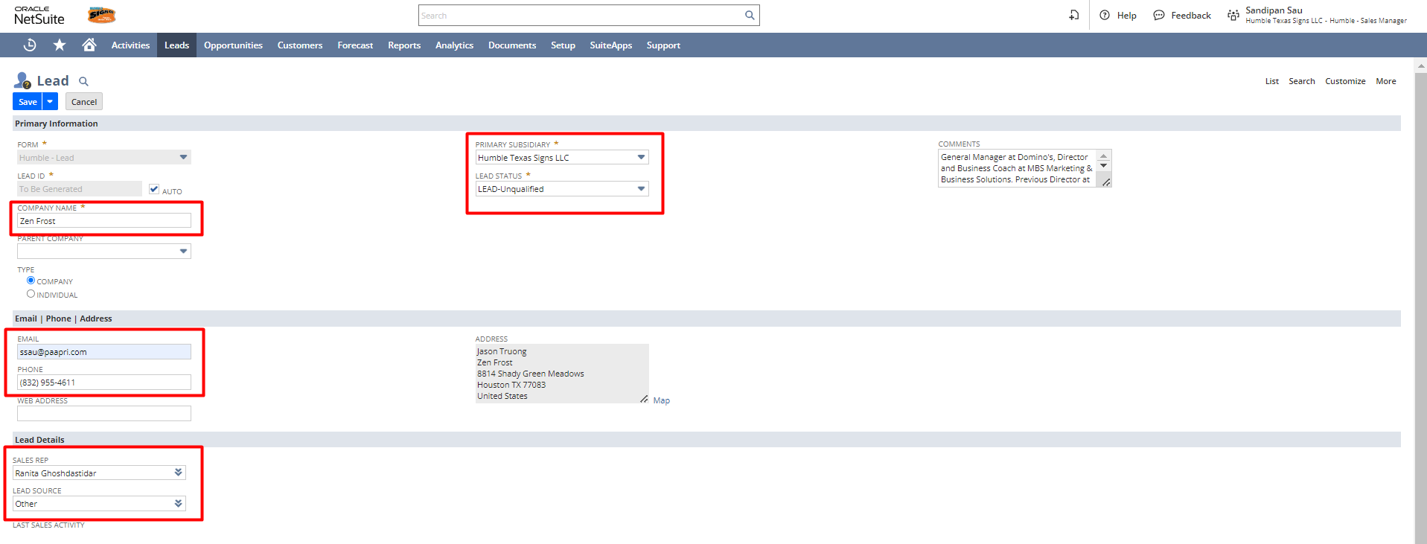

Under the Qualification subtab, enter the following:
- Estimated Budget: Enter the estimated budget the prospect or customer has for this opportunity.
- Buying Reason: Choose the prospect or customer's reason for buying from your company.
- Budget Approved: Check this box if the customer's budget has been approved.
- Sales Readiness: Choose how close the prospect or customer is to purchasing.
- Buying Time Frame: Select the time frame for the prospect or customer to purchase.
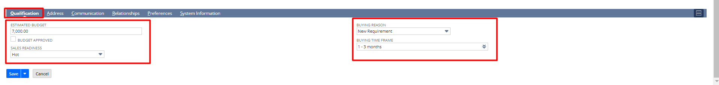

Under the Address subtab, click the Pencil icon and enter the address. If this is the default shipping and billing address, then check the checkboxes.
After putting the address click on Ok to save the address.
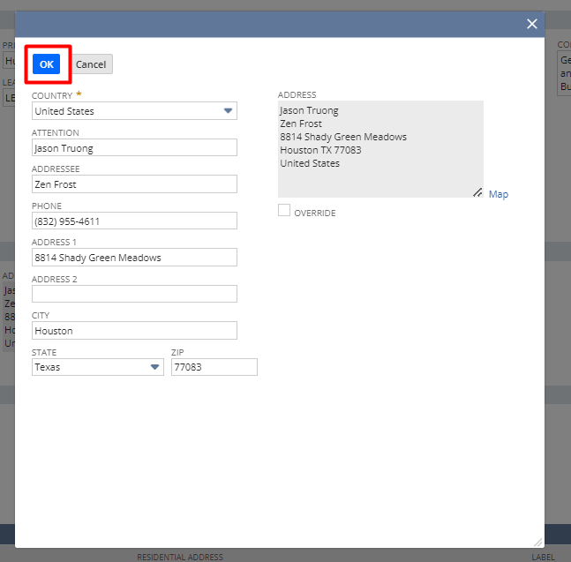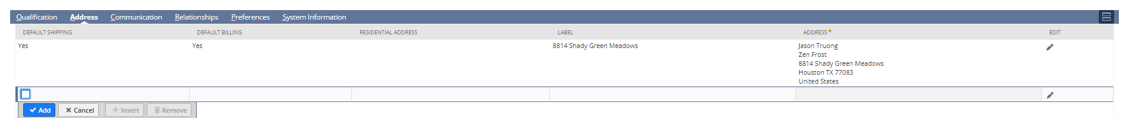
Under the Communication subtab, you can create tasks, events, and phone calls associate with that person.
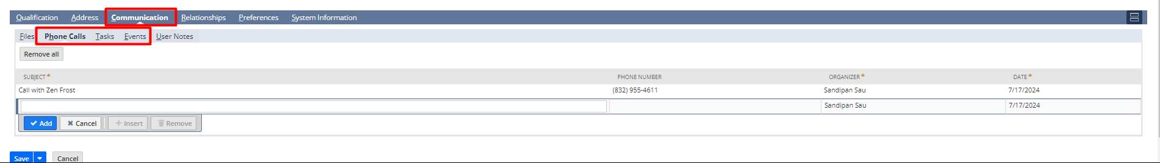

Under the Relationship subtab, you can mention any contact person to whom your sales representative is connected, that contact information can be put over here.
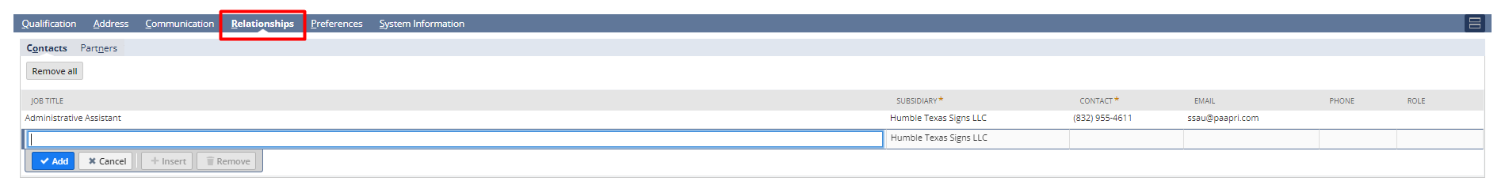
So, after putting all the relevant information click on Save.
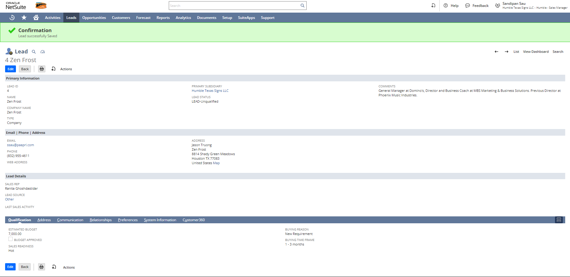

Creating Opportunities
Opportunities represent negotiations with prospects. In NetSuite, you create opportunity records that give sales managers and executives visibility into the pipeline and sales forecast. These records provide reps with a central record for tracking and organizing sales activity.

Sales reps can use opportunities to record the build-up to a deal. For example, reps can attach related tasks, events, files, notes, and messages from the customer. These attachments provide a complete view of the deal as it evolves. Reps can also track competing companies as well as provide reasons why they won or lost the deal.
Navigation: Opportunities -> Transactions -> Opportunities -> New
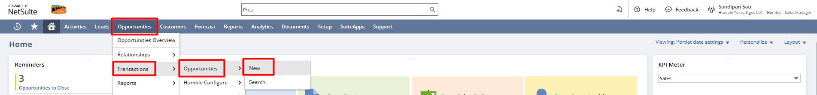

In the Opportunity, form select Company, enter the Date, Expected Close, Status, Probability, and Projected Total. If required enter the Location and Win/Loss Reason, and the Weighted Total will be the Probability % of the Projected Total.
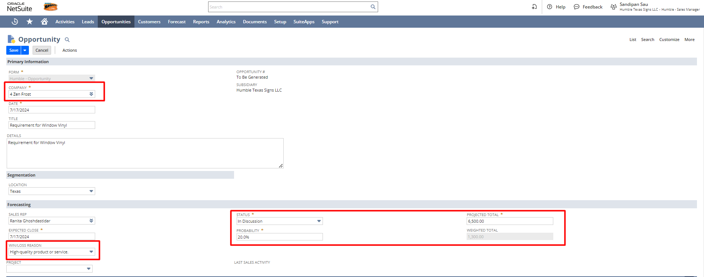
Although the item subtab is not a mandatory section, users can enter the Item from the dropdown, enter a quantity, and provide the rate if required.
Note: Opportunity transaction is the only record which you can save without putting the item information
In the Accounting subtab if there is some profit associated with it, all those information will be coming over here.

In the Sales subtab, you can put the Estimated Budget, Buying Time Frame, Buying Reason and all others details like you had put at the Lead level.
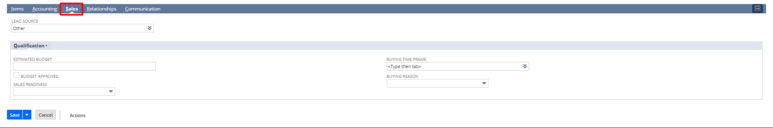
After entering all the relevant information click on Save.
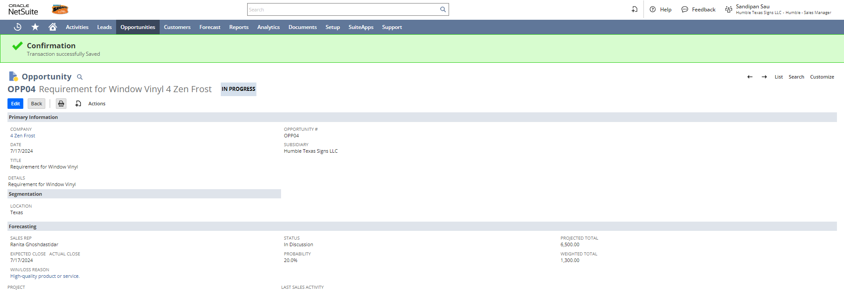
NOTE: If an Opportunity is created with Status selected as “Closed Won” then the Lead gets directly converted into a customer.
As we have created the opportunity the Lead automatically gets converted into a Prospect.
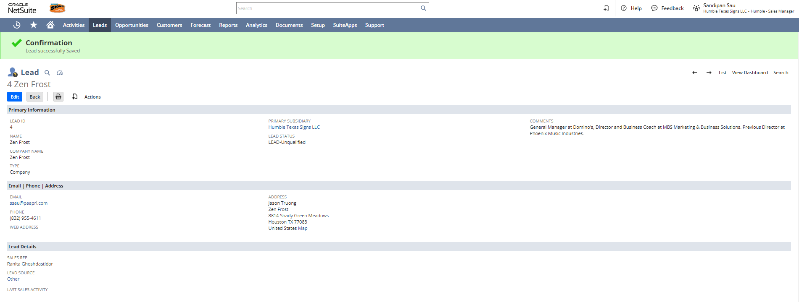

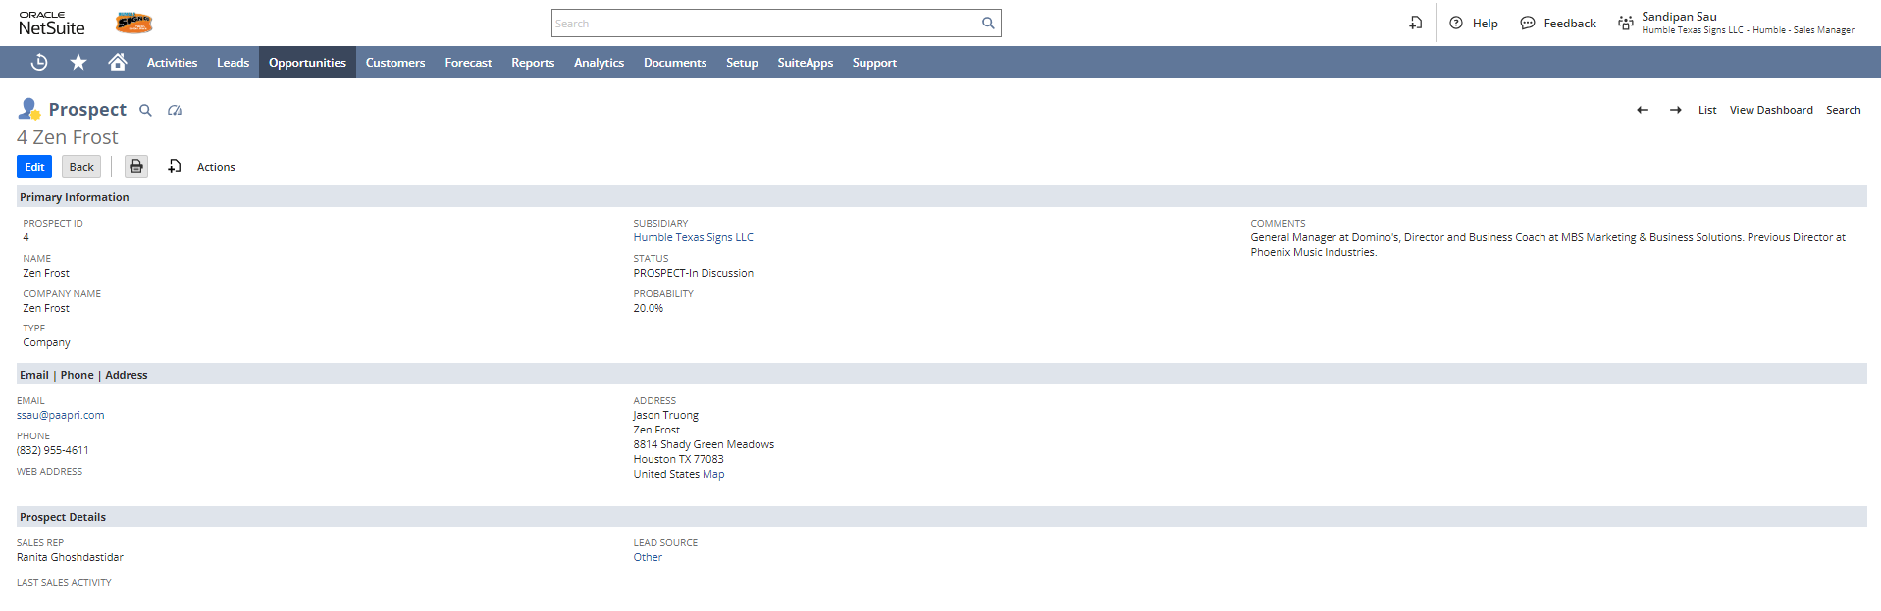
Creating Quotes
Navigation: Opportunity Page -> Create New Icon -> Quote
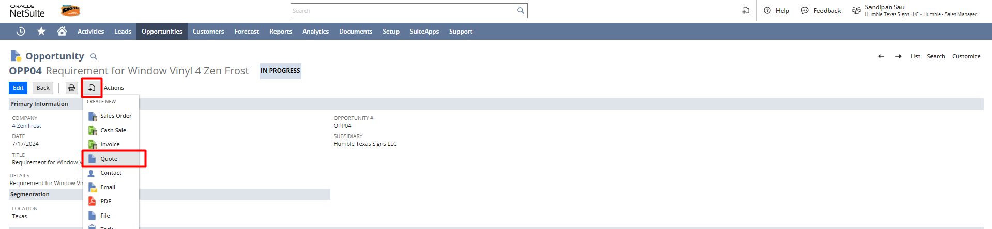
As the Quote page opens all the required details get auto-populated from the opportunity, now just click Save.
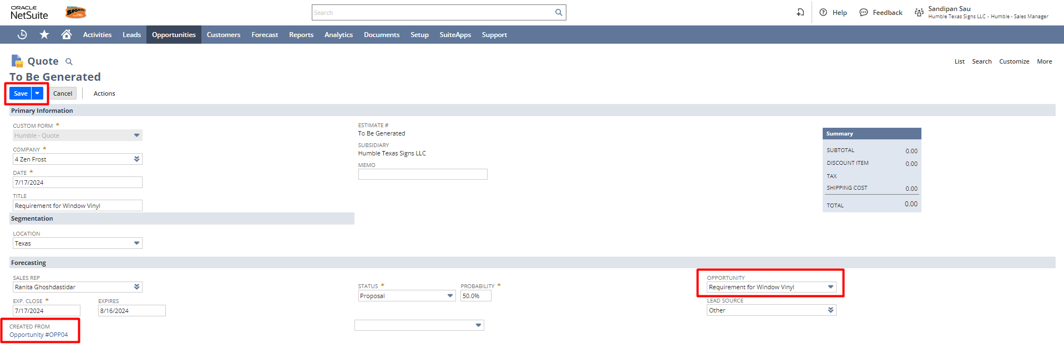
OR
Creating Quotes using Humble Configure
Navigate to Opportunities -> Transactions -> Humble Configure -> New

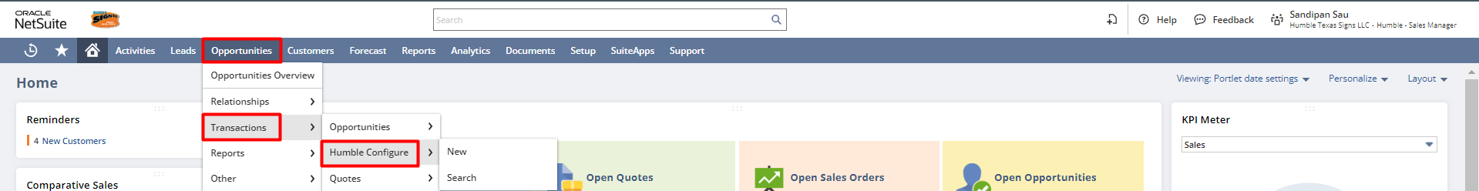

Enter all the required details in the Humble Configure, and click on Save
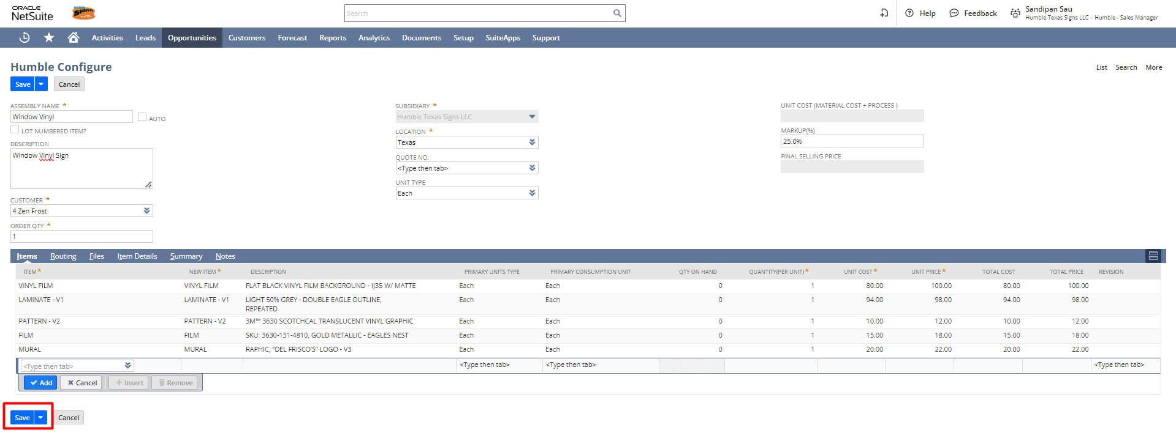
After saving the Humble Configure record click on Create Assembly & Quote button, to create the Assembly and the Quote.
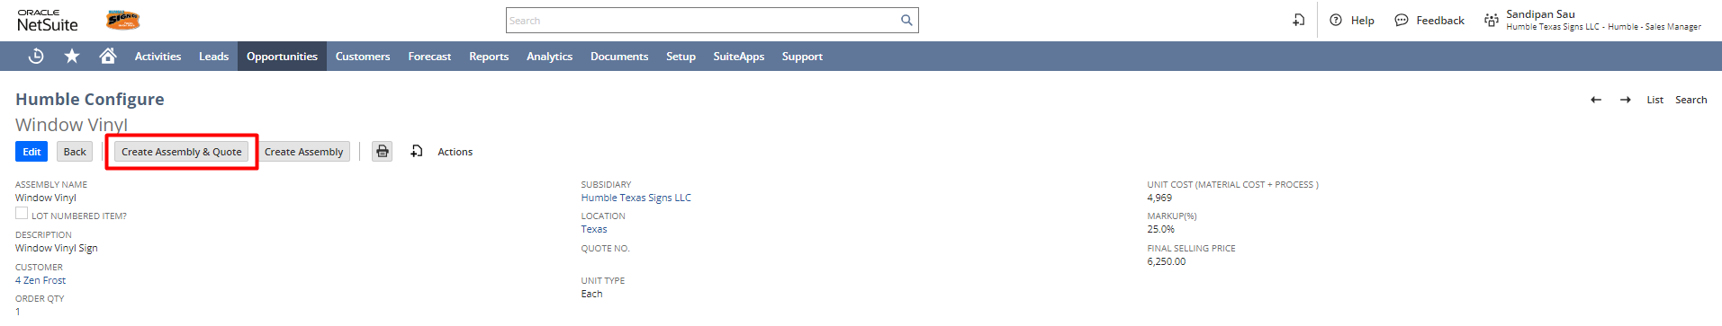

After generating the Quote click on Quote, and the newly created Quote will be opened in View mode.
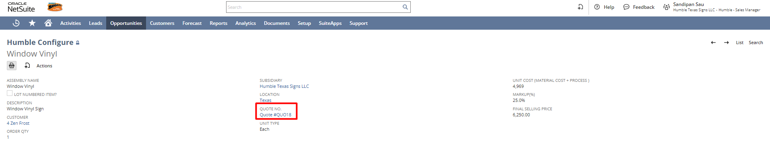
Click on the Edit button to link the Quote with the Opportunity.
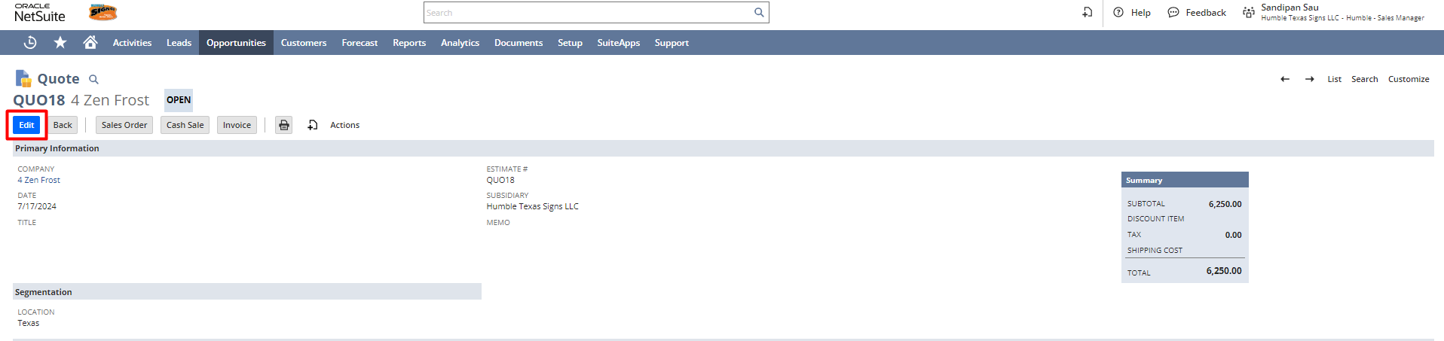
Select the Opportunity from the dropdown and also in the Item subtab select the Items like Design Proof, Field Survey, Installation and others relevant services click on Save.
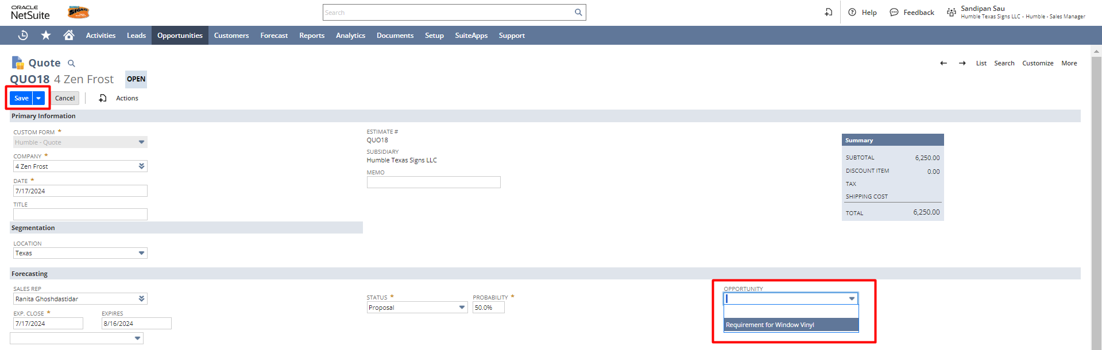
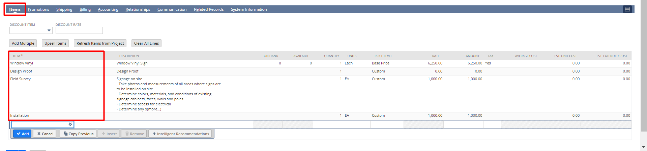
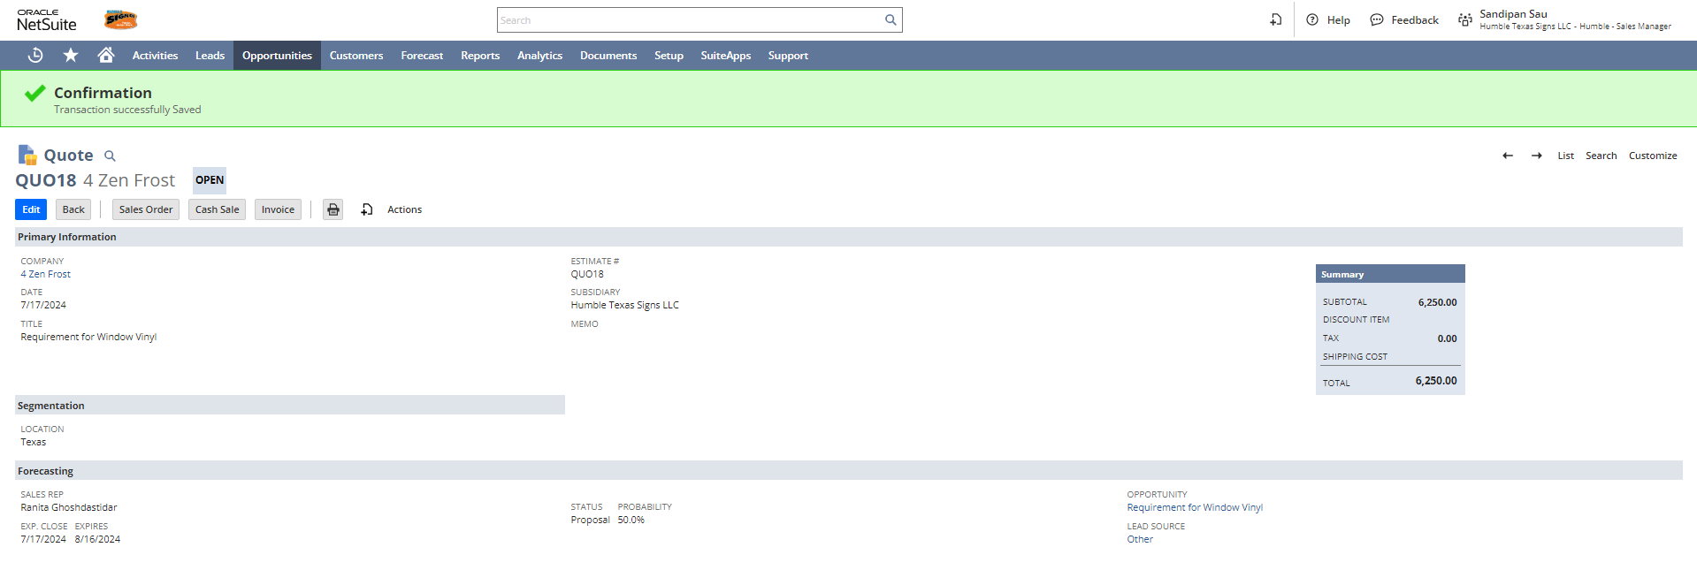
To print the Quote click on the print button.
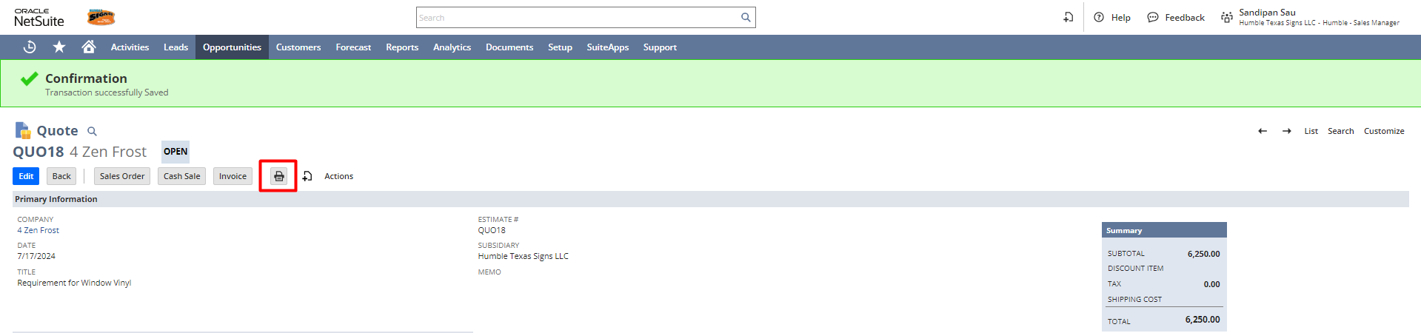
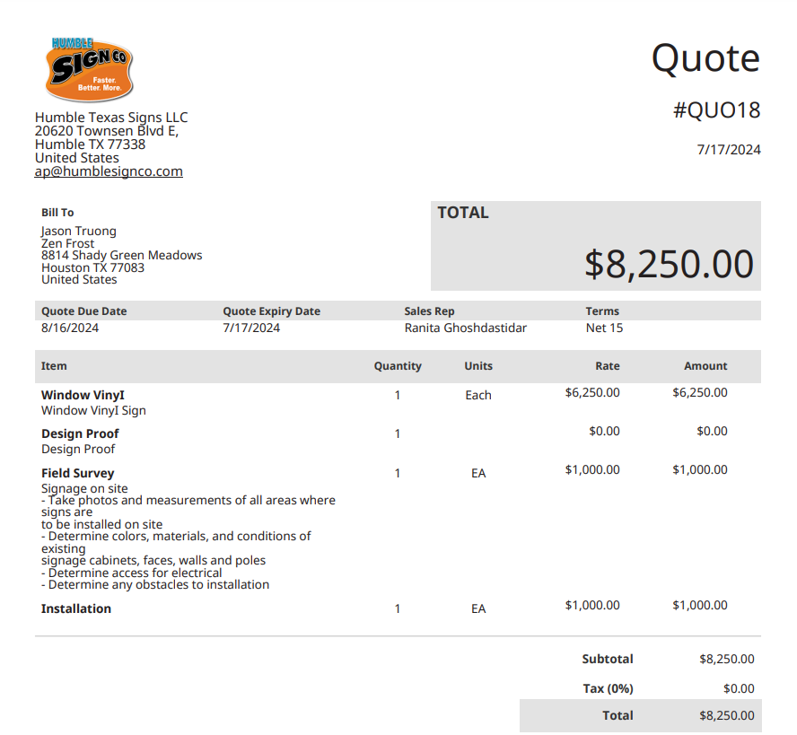

Signature: ________________________________
Date: _____________________________________

Disclaimer:
Upon signing off on the process flow document, you are confirming that the process has been set up per the SOW within NetSuite per your business's needs. Any changes or modifications requested after sign-off will need to be a "change request" at an additional fee.

*** PLEASE ensure that you have logged into NetSuite and tested the process prior to signing off on the setup. Paapri requires sign-off on this document prior to moving forward with any additional design meetings.

